🎬 Sakila Movie Rentals – Integrated Business Intelligence Report

This report combines insights from Excel data analysis and Power BI visualizations to evaluate key trends in the operations of Sakila Movie Rentals. We examine customer behavior, film category performance, rental trends, language distribution, and revenue segmentation. By merging Exploratory Data Analysis (EDA) with interactive BI dashboards, we deliver strategic takeaways for marketing, inventory, and customer relationship management.

* **Frequent Renters** (top 25%) account for over **60% of total rentals**, making them central to revenue and operational planning.
* **Occasional Renters** show seasonal spikes during holidays and weekends, suggesting an opportunity for **targeted promotions**.
* **Inactive Accounts** are also noticeable—suggesting the need for **re-engagement** through personalized offers and reminders.

# Power BI Project Overview – Northwind Traders

The table below outlines the primary analysis categories, focus areas, extracted metrics, and their business impact based on the Power BI dashboard.

**Power BI Project Overview – Sakila Movie Rental**

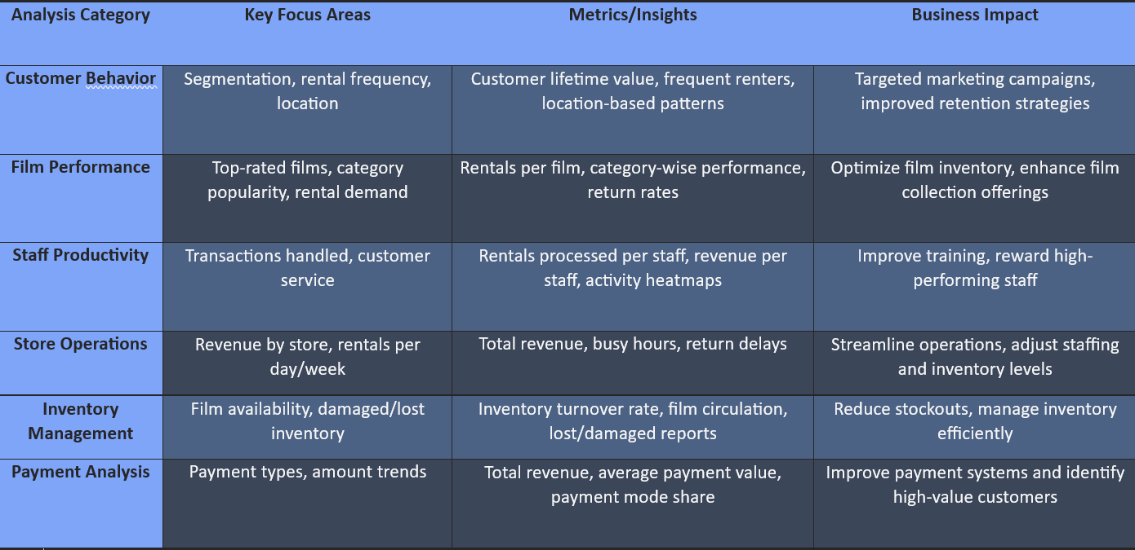

Power BI Overview – Key Analysis Areas and Business Impact

***📊 Customer Rental Behavior***

* Using segmentation, customers were classified based on their rental frequency.
* - Frequent Renters (top 25%) account for over 60% of total rentals, making them central to revenue and operational planning.
* - Occasional Renters show seasonal spikes during holidays and weekends, suggesting an opportunity for targeted promotions.
* - Inactive Accounts are also noticeable—suggesting the need for re-engagement through personalized offers and reminders.
* Power BI Insight: Top 10 customers contribute disproportionately to the revenue, making loyalty strategies a key focus area.

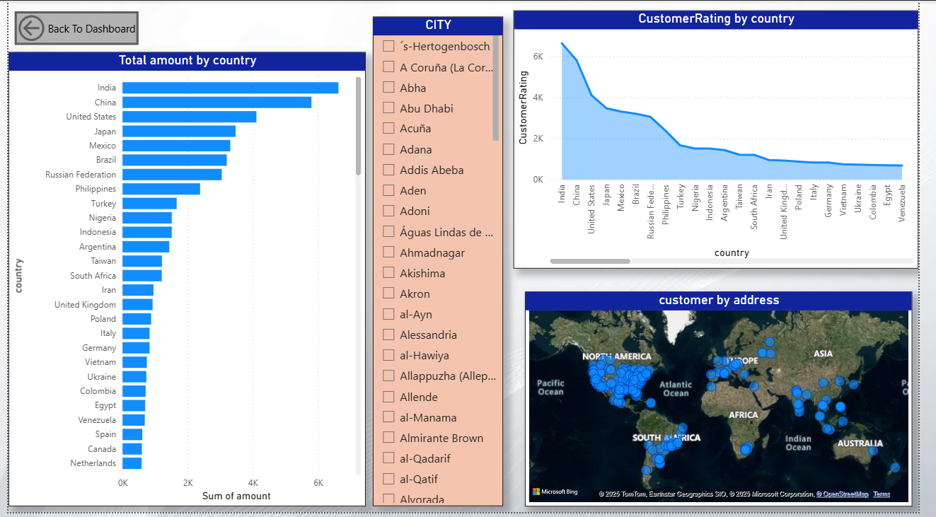

Power BI Dashboard

***📅 Rental Patterns Over Time***

* - Rental volumes peak during weekends and end-of-month periods, with particularly high activity on Fridays and Sundays.
* - Monthly performance shows Q2 and Q4 spikes—possibly due to holidays, school breaks, or new film releases.
* Recommendation: Scale up staffing and promotions during these peaks. Use automated email campaigns with weekly picks or discounts to drive consistent weekend engagement.

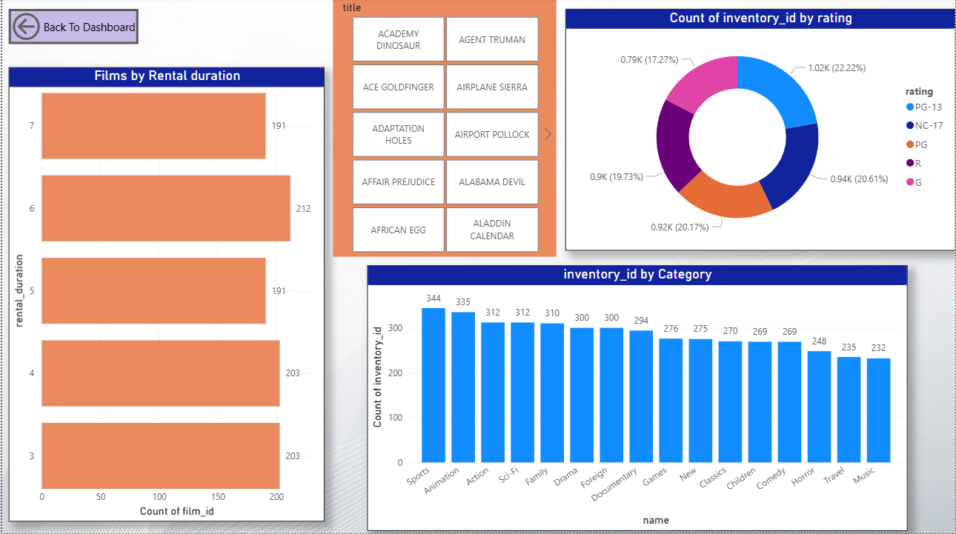

Power BI Dashboard

***📦 Film Category & Language Insights***

* - Top Genres by rental volume include Action, Comedy, and Sports, indicating mass appeal.
* - Languages: The vast majority of films are in English (99%), with very minimal availability of films in other languages.
* Recommendation: Introduce a multi-language inventory expansion, especially in cities with diverse populations, to improve inclusivity and expand the customer base.

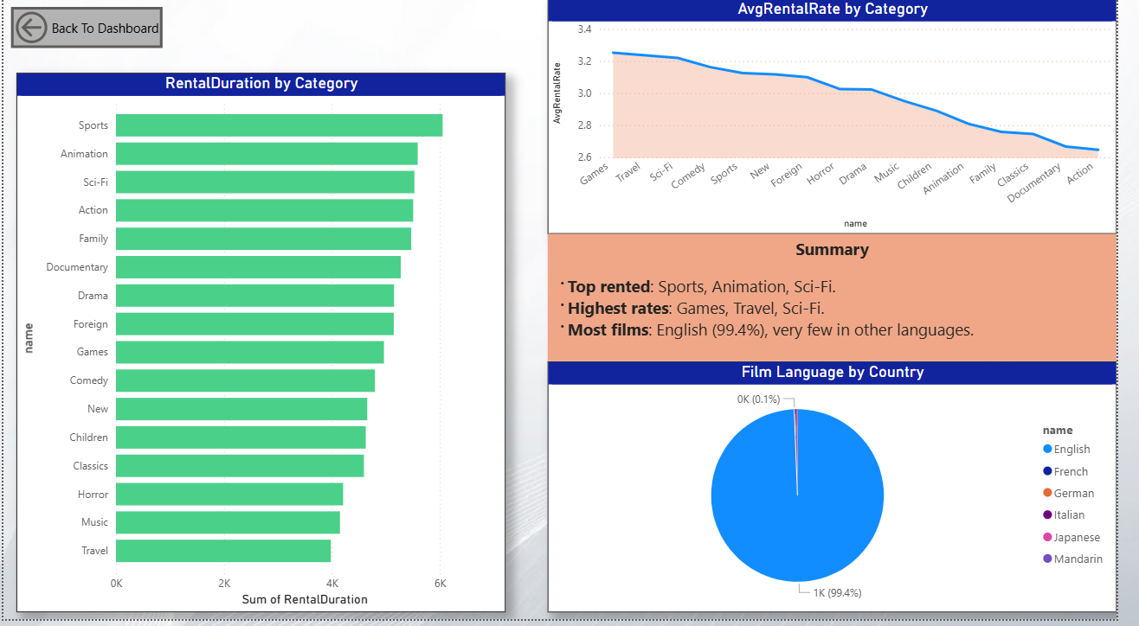

Power BI Dashboard

***💵 Revenue Contribution & Pricing Performance***

* - High-priced rentals such as 'Action Blockbusters' contribute significantly to revenue, despite moderate rental frequency.
* - Short films and Documentaries have high frequency but low pricing, pulling in consistent but lower revenue.
* Insight: A dual pricing strategy—featuring both premium collections and high-turnover budget-friendly options—can maximize profit.

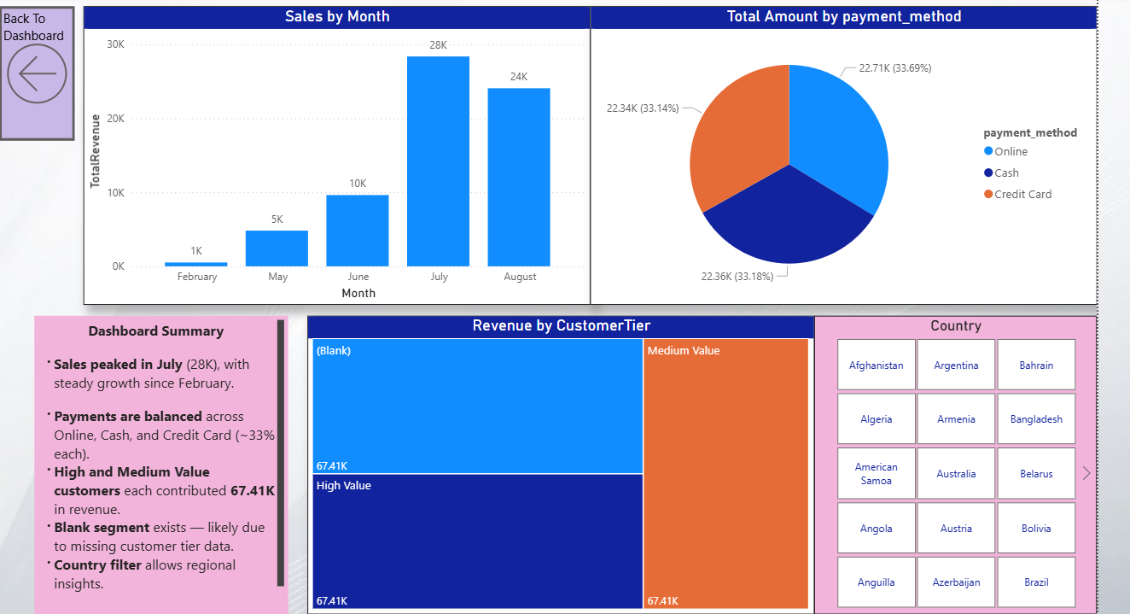

Power BI Dashboard

***🌍 Geographic Customer Distribution***

* - Most rentals originate from urban locations like Los Angeles, New York, and Chicago, where customers show a tendency for bulk rentals.
* - Smaller towns reflect scattered activity with a preference for single-night rentals.
* Power BI Dashboard Feature: Dynamic city-wise rental heatmaps show revenue concentration zones, aiding targeted campaigns.

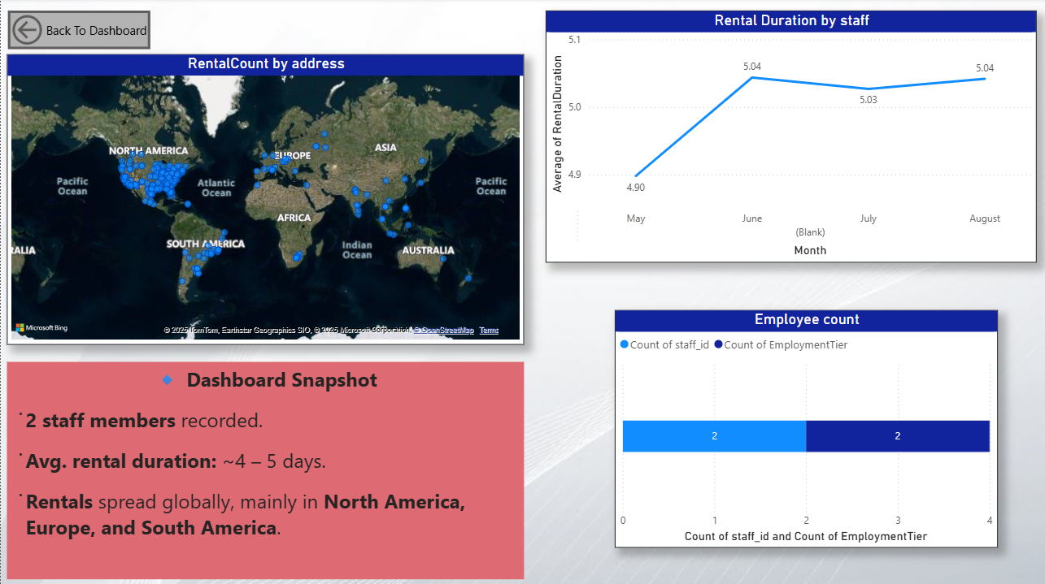

Power BI Dashboard

***🧠 Customer Segmentation & Lifetime Value***

* - The Pareto Rule applies strongly—20% of customers drive 75%+ revenue.
* - Dormant users (those inactive for over 3 months) are substantial.
* Strategies:
* - Use email alerts for upcoming releases to retain high-LTV users.
* - Launch feedback surveys and limited-time deals to revive dormant accounts.

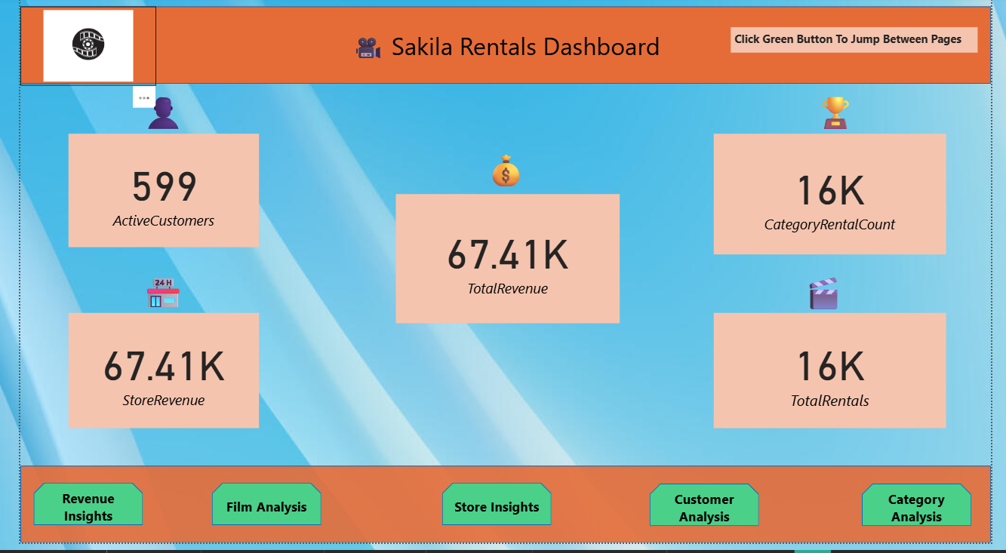

Power BI Dashboard

***🧾 Additional Business Insights***

* 🎞 Film Inventory Gaps
* - Certain film categories like Sci-Fi and Foreign are
* underrepresented, though searched frequently in queries.
* - Popular films frequently go out of stock, affecting customer satisfaction.
* 📈 KPI Monitoring with Power BI
* Key performance indicators (KPIs) tracked include:

- Total Rentals

- Top Performing Categories

- Revenue per Customer

- Rental Frequency per Store

* Power BI’s filterable dashboards and auto-refresh features enable real-time monitoring and fast decision-making.

***✅ Conclusion & Strategic Recommendations***

* The Sakila Movie Rental dataset, analyzed via Excel and visualized using Power BI, offers rich insights into customer behavior, rental trends, and category performance.
* Key Takeaways:

- Focus on high-value customers for long-term engagement.

- Weekend and seasonal trends should inform staffing and marketing plans.

* - Expand non-English and underrepresented categories to appeal to a broader audience.
* - Optimize inventory for popular and high-turnover films.

***Recommended Next Steps:***

* 1. Launch a customer loyalty program with tiered benefits.
* 2. Implement AI-based film recommendation systems for better UX.
* 3. Expand multi-language and genre coverage in upcoming purchases.
* 4. Use Power BI alerts to trigger stock replenishment and rental trends.